**INDIA’S AGRICULTURE CROP PRODUCTION ANALYSIS (1997-2021)**

**Submitted by**

**Team id**

**NM2023TM ID:19968**

**Team members id**

**EYAL S.I. : 1F2FA55E9D76A8D9D0F481514AD8C03E**

**ANUSIYA.M: D4153EFD8EC16F18E364EB55FC2E47BA**

**DHANALAKSHMI.P: 39E7F2FF303B896915A47D22B81DC5C7**

**DHARSHINI.R: AD8D21E02A01D49A77B41F247C49F8E1**

**Under the guidance of**

**Dr. K. Lilly Mary Eucharista**

**Assistant Professor**

**Department of Physics**

**Sri Meenakshi Government Arts College for Women (A)**

**Madurai – 625 002**



**October 2023**

**Sri Meenakshi Government Arts College for Women (A)**

**Madurai – 625 002**

**INDIA’S AGRICULTURE CROP PRODUCTION ANALYSIS (1997-2021)**

**PROJECT REPORT TEMPLATE**

**1. INTRODUCTION :**

**1.1 OVERVIEW:**

The analysis of India's crop production involves studying the trends, patterns, and factors that influence the country's agricultural output. This analysis typically involves examining data on crop yields, production, etc. Overall, the analysis of India's crop production provides valuable insights into the country's agricultural sector.

**1.2 PURPOSE:**

**USE :**

It helps in identifying the crops that are suitable for a particular region and the best practices for their cultivation. It also helps in identifying the crops that have the potential to generate higher income for farmers.

**ACHIEVEMENTS :**

In India, there have been significant achievements in the analysis of crop production in recent years. The government has implemented various initiatives to improve the accuracy of crop production estimates, such as the use of remote sensing technology and satellite imagery. The Ministry of Agriculture and farmers Welfare also conducts regular surveys to collect data on crop production, which is used to estimate the country's overall agricultural output. Additionally, private companies and start up are developing innovative solutions using artificial intelligence and machine learning to analyze crop production data and provide insights to farmers. These efforts are helping to improve the efficiency and productivity of India's agriculture sector.

**2. PROBLEM DEFINITION & DESIGN THINKING:**

**2.1 EMPATHY MAP:**

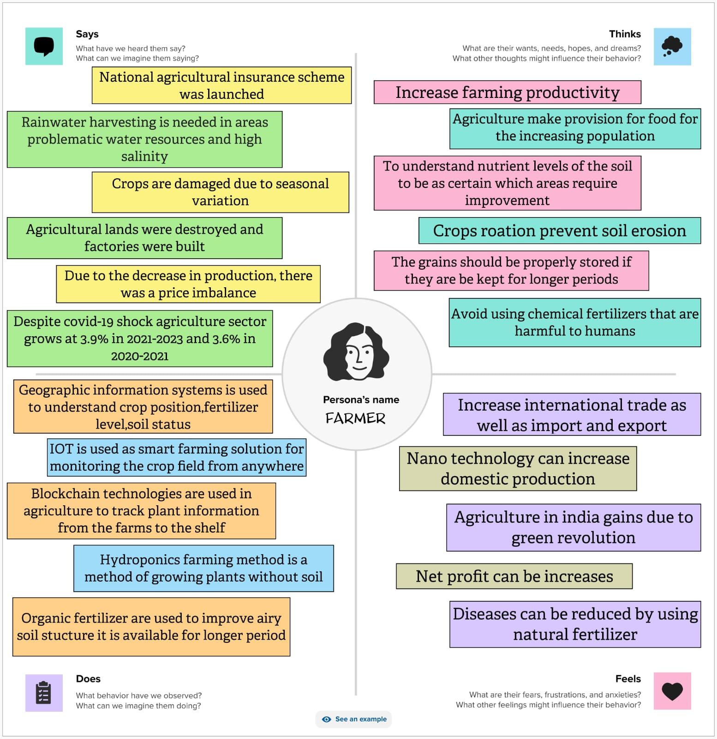

**2.2 IDEATION & BRAINSTORMING MAP:**

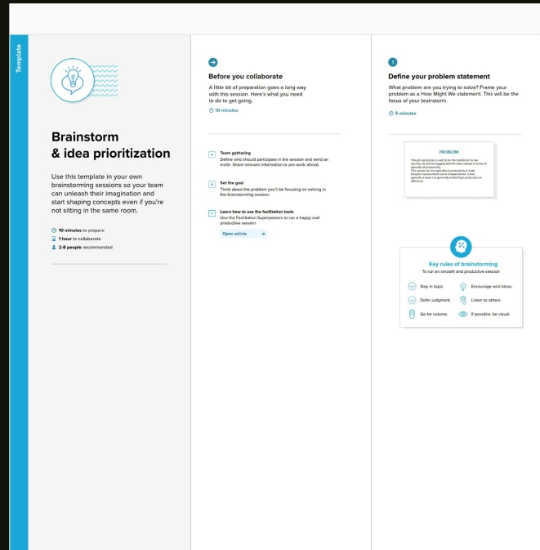 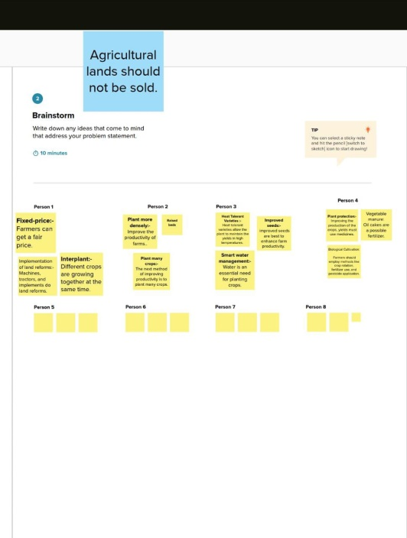

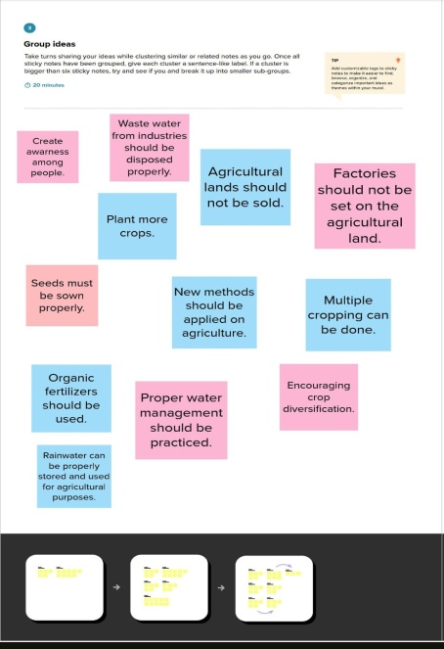 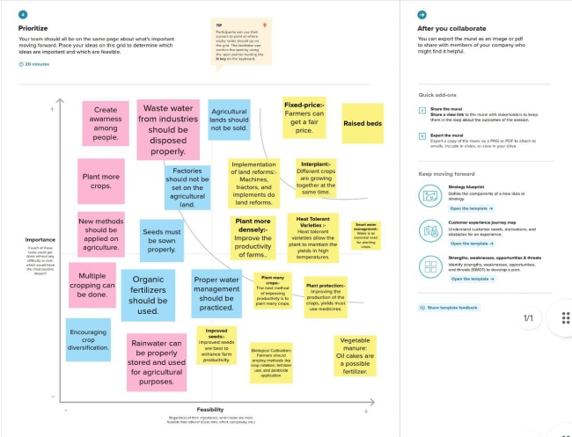

**3.RESULT :**

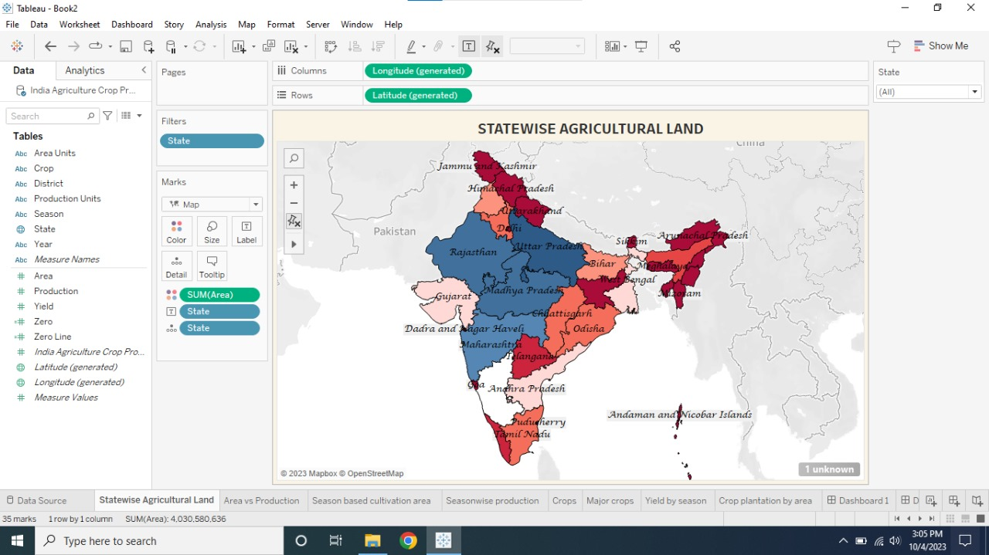

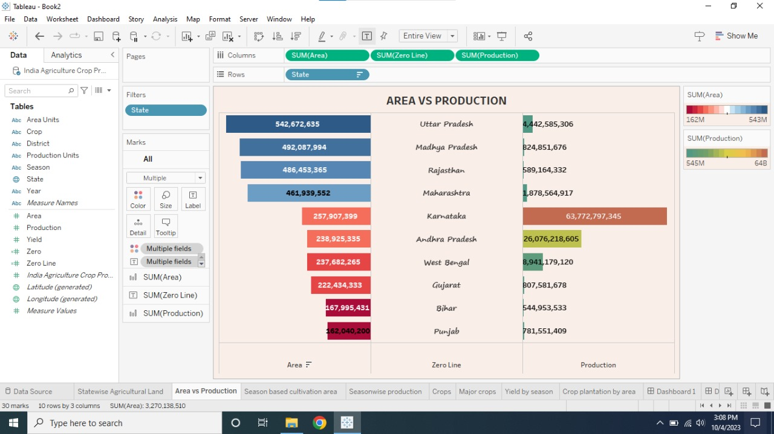

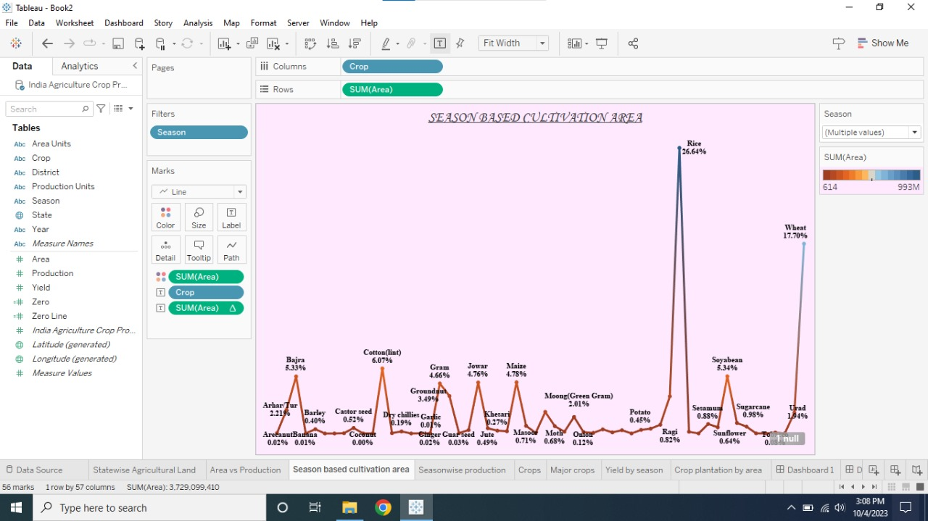

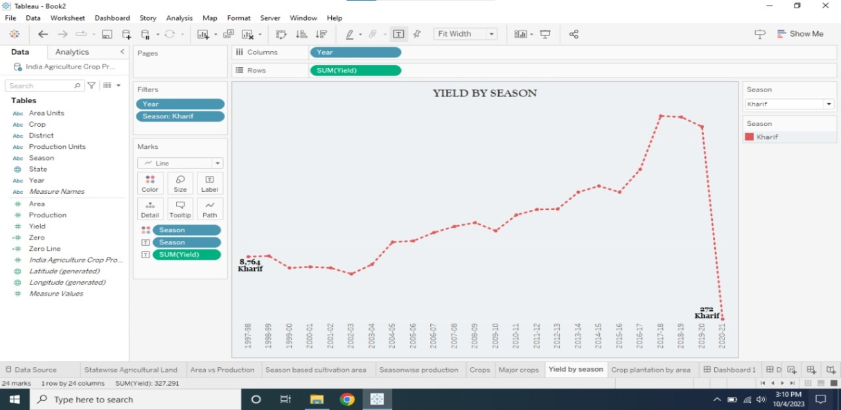

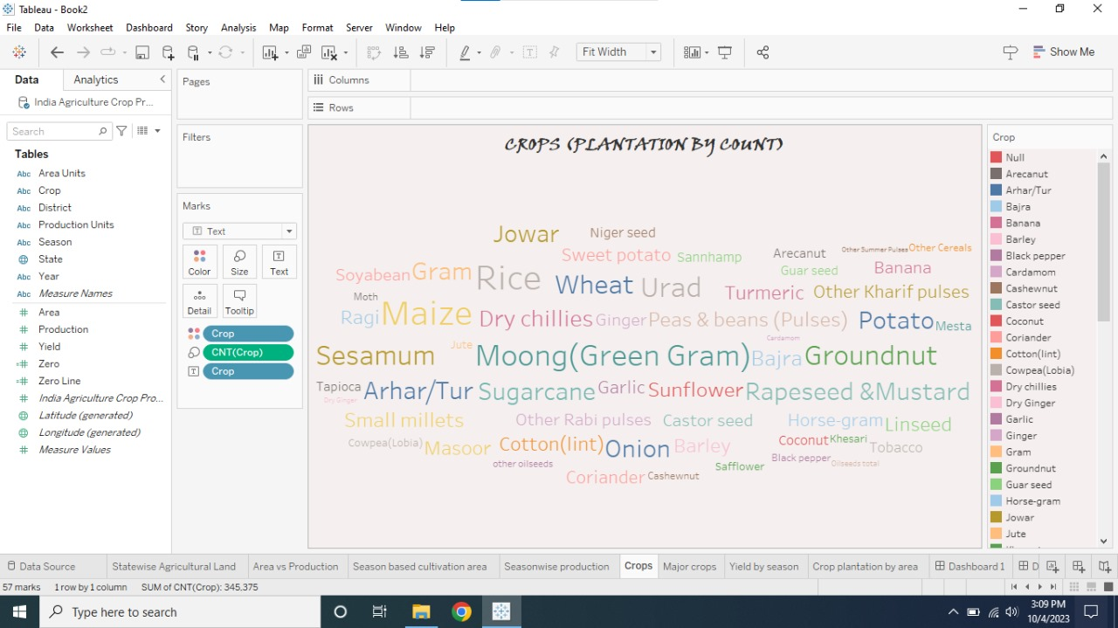

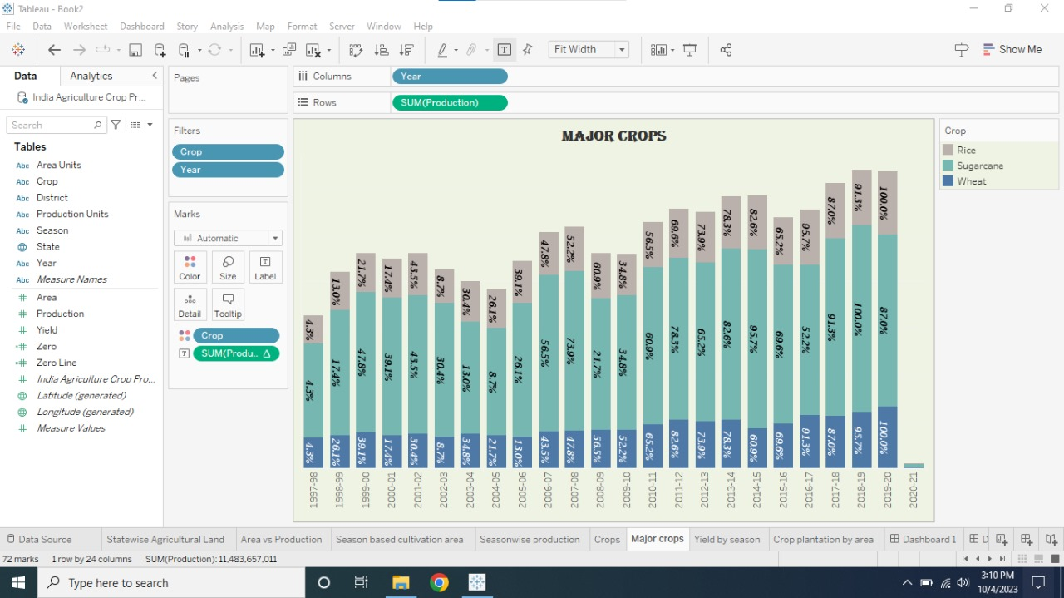

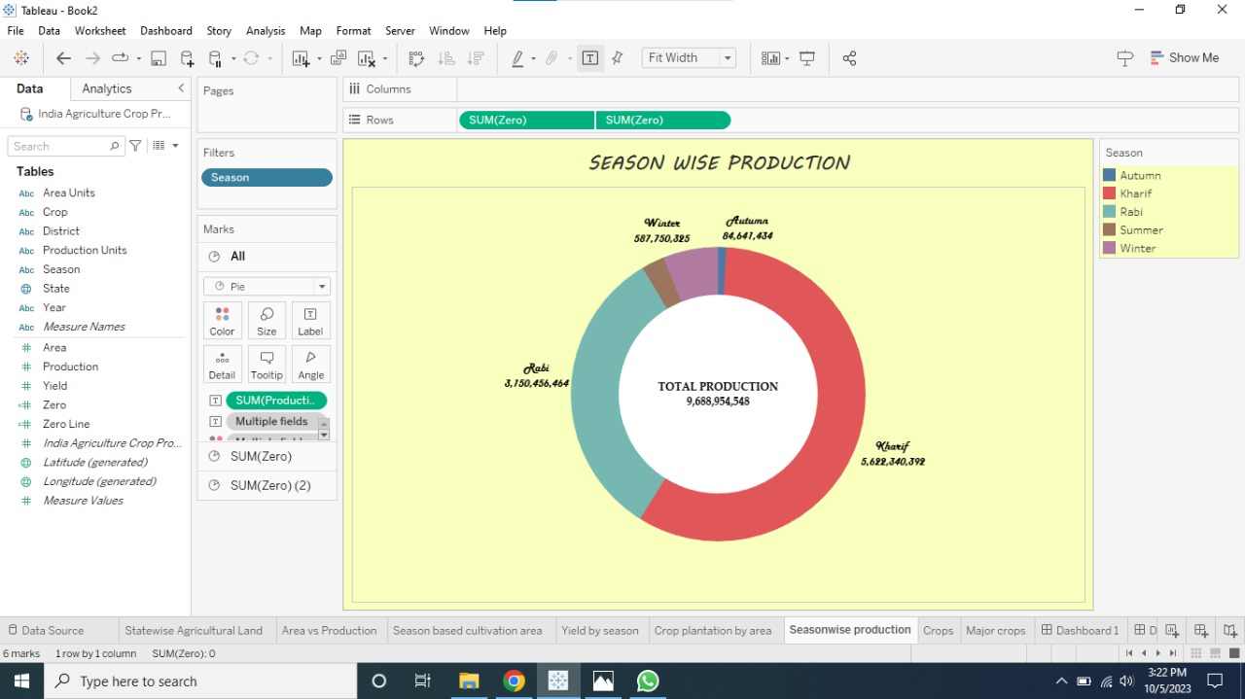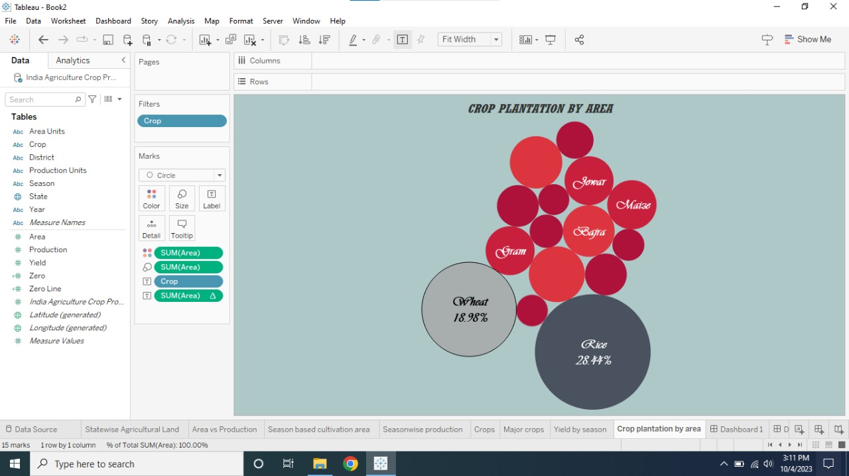

**4.ADVANTAGES & DISADVANTAGES:**

**ADVANTAGES:**

* Improved crop planning
* Increased productivity
* Better resource management
* Improved food security
* Better market access

**DISADVANTAGES:**

* Limited accuracy
* High cost
* Time consuming
* Limited scope
* Lack of awareness

**5.APPLICATIONS :**

* Crop production analysis is a crucial aspect of agriculture that helps farmers and policymakers make informed decisions about crop management, resource allocation, and food security. Here are some of the applications,
* Yield forecasting.
* Soil fertility managemen
* Pest and disease management
* Water management
* Crop diversification

**6.CONCLUSION :**

India is one of the world's largest agricultural producers, with a diverse range of crops grown across the country. India's crop production has shown significant growth in recent years, there is still much work to be done to ensure sustainable and equitable agricultural development in the country.

**7.FUTURE SCOPE :**

Crop production analysis has a vast scope for the future, especially in India, where agriculture is a significant contributor to the economy.